1. What CSS means? Cascading Style Sheet

What is the last version of CSS? CSS3 What is it used for? You can add style properties to HTML files (it can go from changing a color to create animations)

2. Which tool can you use to help you make sure your CSS code is correct? CSS lint or w3c css validation service

3. What is a CSS Rule? Give an example.

It consists of a selector and a declaration block

Ex. P { text-align: center; color: red; font-weight:400;}

4. What is a CSS Selector?

Pattern used to select HTML elements, it can be by class name or id name.

Give an example. Try the CSS Selector Tester in <http://www.w3schools.com/cssref/trysel.asp>

5. How several properties are included in a CSS rule? Give an example.

They are inside { } or they can be nested

.summary-part {

text-transform: capitalize;

color: blue;

background-color: blue;

opacity: 0.8;

}

6. What is the difference between the selector class and the selector id? How are they used? Give examples.

In the stylesheet the id starts with # and the class with . on the beginning of the html element selected.

#first-column {} 🡪 Refers to an element with ‘first-column’ name as id.

.first-column {} 🡪 Refers to an element with ‘first-column’ name in a class.

7. What are three ways of inserting a style sheet in an HTML document? Give a description and an example of each one.

1. Add <style></style> tags inside the HTML file and you write css code inside. This tag goes inside the head section also.

2. Add a link to the HTML file on the head section, <link rel=”stylesheet” type=”text/css” href=”style.css”/>

3. You can write the style inside each tag… example:

<h1 style=”color:pink; text-align:center”>Alejandra</h1>

8. How CSS comments are defined?

You can define them by adding “//” in the beginning in case is just a one line for the comment, but if it’s more than one line its better to write the comment inside /\* Write comment here \*/

List exercises.

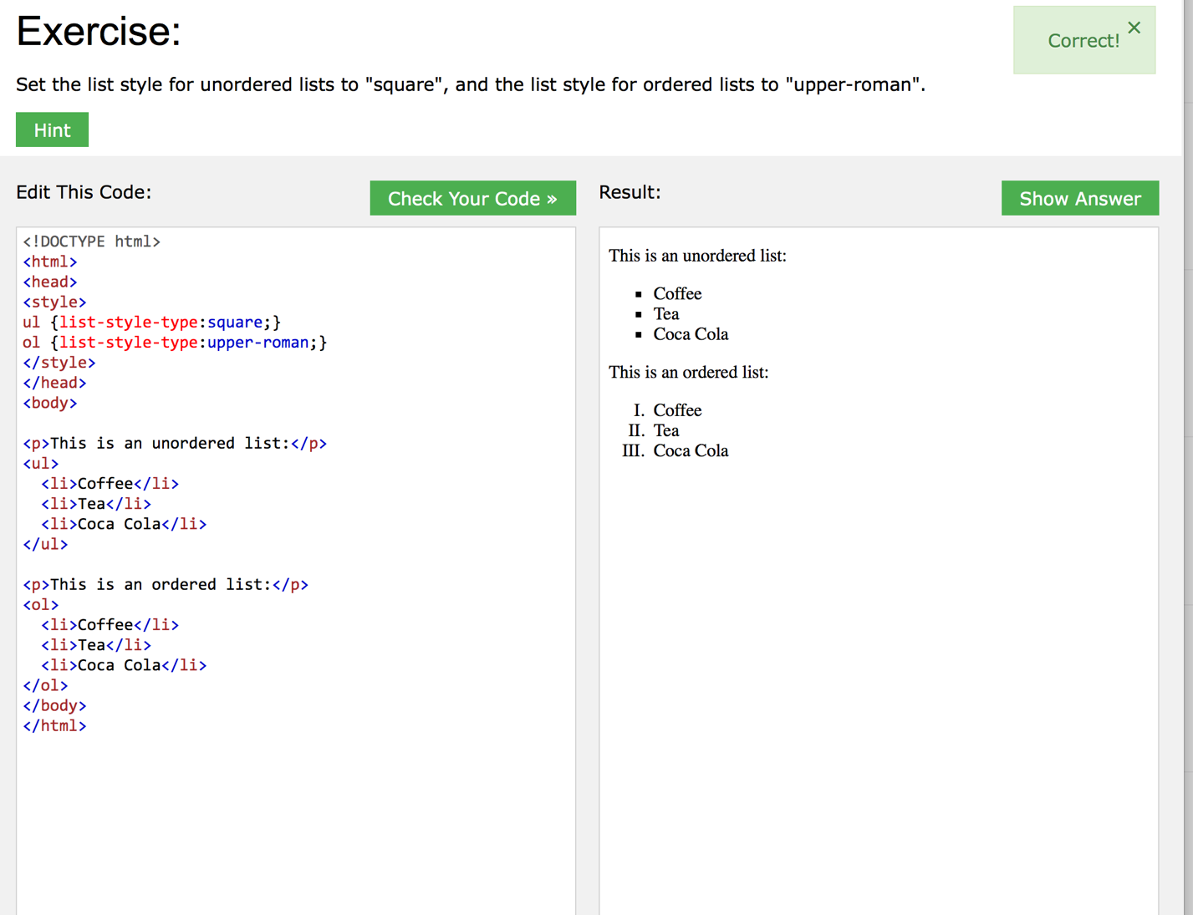

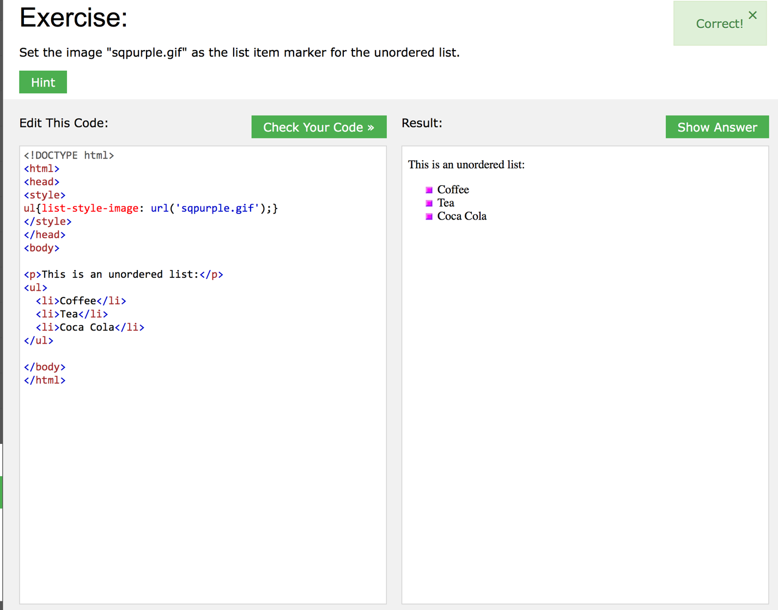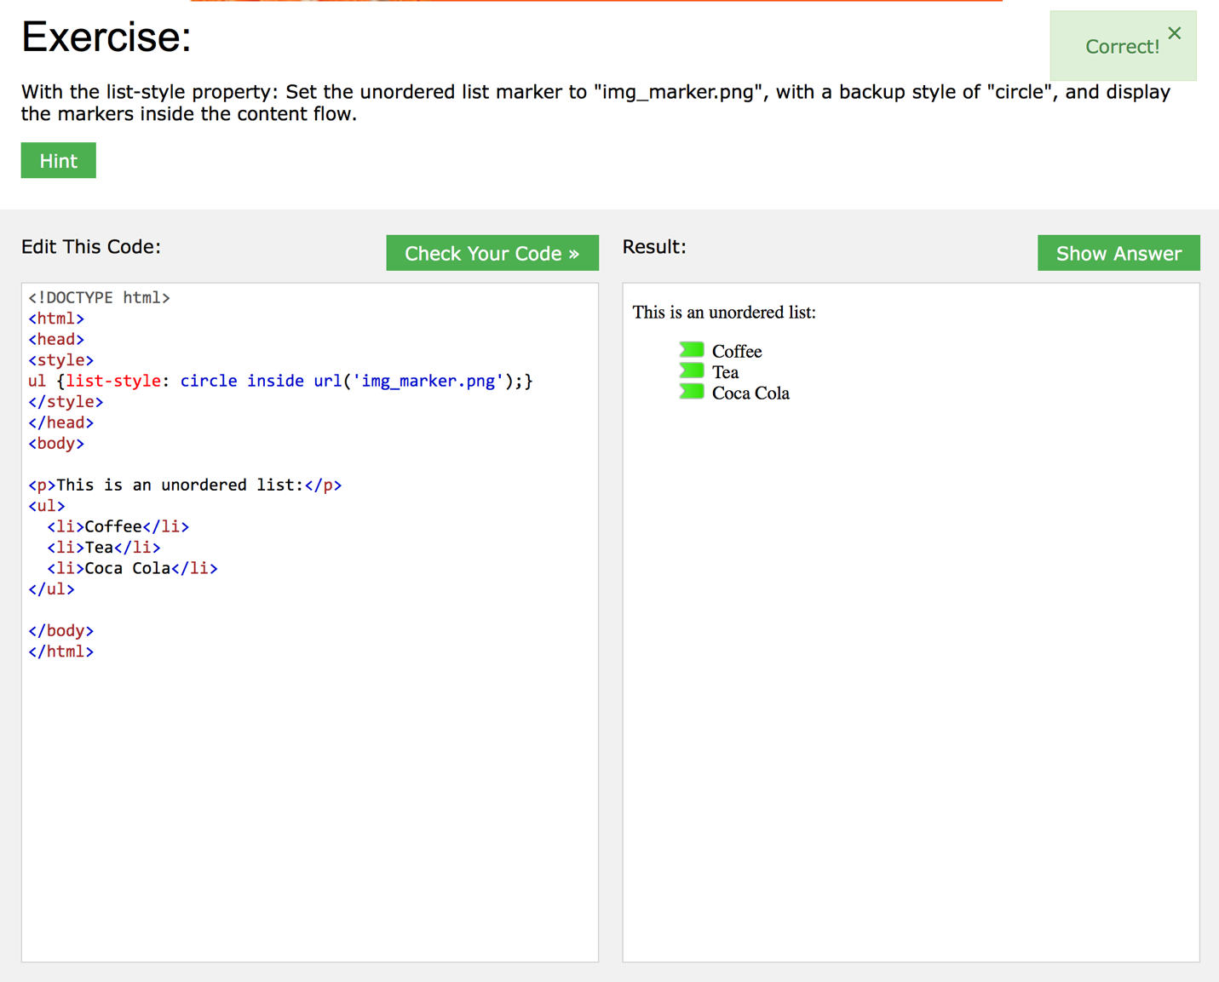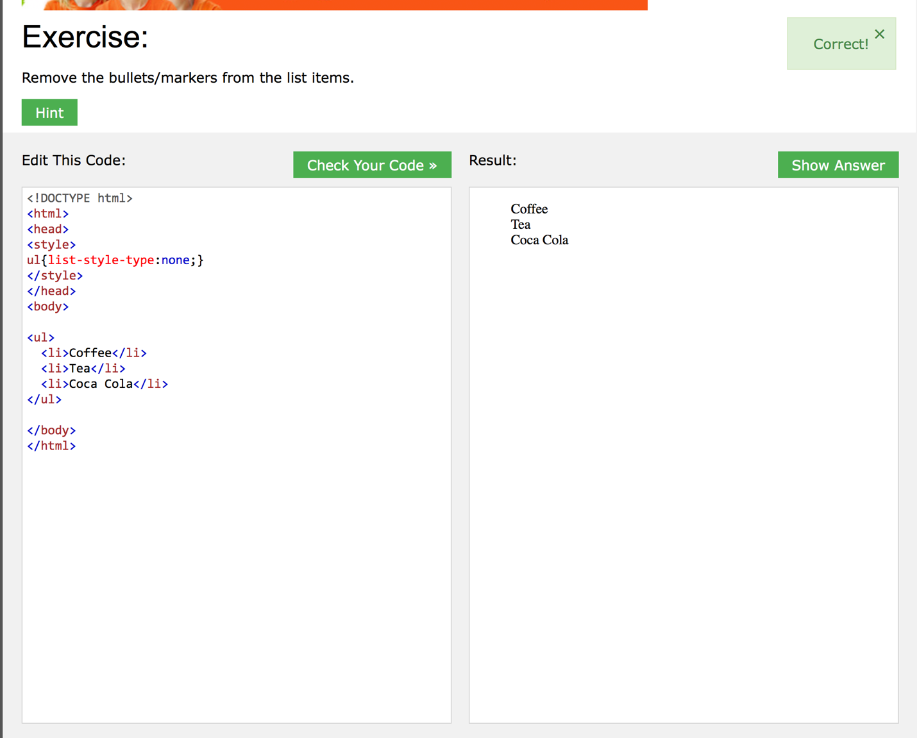



Table exercises